Batch Render
Change Request / Counter Proposal
Local Rendering + JSON Configuration

Summary
I do not wish to use other forms of cloud compute to process renderings. I will instead utilize a dedicated machine and process all renderings locally. Instead of working on other forms of cloud compute, I would like to work on issues I have been having with the plugin. Once addressed, final payment will be released.

1. JSON Configuration File (Render Instructions)
Introduce a single JSON file that drives all dynamic behavior. This removes hard-coded values and allows per-file control which is needed to properly size decals. To utilize, a new User-selectable field called “Render Instructions Location” is to be added to the UI. See renderingInstructions.txt for structure.

Implementation Notes
- decals
  - width / height are the full desired sizes.
  - Independent X/Y scaling is achieved by setting the magnitudes of the X and Y vectors in the Decal transform matrix. The official Fusion API explicitly supports non-uniform magnitudes. Do not look for non-existent horizontalScale / verticalScale properties.
- renderConfigurations:
  - Activate the named view.
  - Hide the bodies or components listed under “hideBodies”.
  - Render at the selected quality.
  - Restore visibility as needed before the next configuration.

2. UI Changes
Please update the UI as follows:
Change | Action
Title | Rename “Lifeproof Batch Render” → Batch Render
“Pick Texture Folder and models with file dialogs…” | Remove
“(full path, when browse is off)” text | Remove
Image width (px) | Set default to 2000
Image height (px) | Set default to 1130
“Max Named Views per color set…” | Remove (will be determined in JSON file)
“Render Backend” | Remove (will only be local)
“APS network concurrency (threads)” | Remove (No longer applicable)
“If APS fails, fall back to local…” | Remove (No longer applicable)
New field: Render Instructions location | Text input – path to the JSON file
New field: Render Quality | Dropdown: Draft (25), Standard (50), Final (75) ← default, Excellent (100)
See desired UI below:
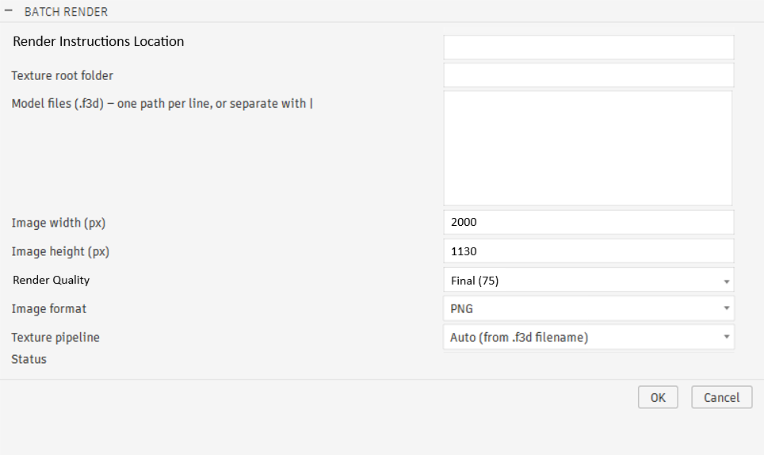

Deliverables Expected
- Working JSON-driven configuration as described above.
- Provide independent X/Y decal scaling using the Decal transform matrix magnitudes (centimeters).
- Hide/Show of bodies/components per render configuration.
- Cleaned-up UI matching the image above.
- Local Render-only code. Remove all code regarding APS and viewports.

Let me know if this is acceptable and if you have any additional questions.

Hi,

I understood fully your requirements, so you want the render mode with JSON locally. I thought it is good idea and agreed, before that, I wanted to let you know quick set of question before I start building the JSON-driven rendering update.
(I’d like you to confirm them like this. If you thought that is Yes, then please make it as red color. “Yes, exact match (_________________)”, If not, then please describe your requests exactly on the (______), like “No, here how they are actually named: (____________________)”, )

- Part names in Fusion.
Your instructions file (json file) lists part names like “Stair Nose” and “Supplemental Plank”. Are these the exact names of the parts as they appear inside the Fusion model files? (I ran into a naming-mismatch issue earlier in the project, so I want to double check this matches exactly before building on it.

- Yes, exact match (_________________)
- No, here how they are actually named: (__________Thank you for the feedback. I went through and updated the fusion files and txt file so that now, they do match 100% (as far as I can tell.) Prior to this, there were discrepancies. Please see the new files.__________)
- "Hide" instructions
When the file says to hide "Supplemental Plank" or "Track" for a particular image, are these referring to whole parts/components (same naming as question 1), not individual pieces inside a part?

- Yes, whole parts/components – Yes you hide the entire Component / Body. To locate it, you will search for the Part Number.
- No, please explain: _______________
- Matching files to models
The "fileName" field (e.g. "Bullnose," "Square Nose") should match the model file's name. Two follow-ups:
- Is a simple name match (ignoring capitalization and the .f3d extension) good enough, or could two different files share a similar name? – Yes ignore capitalization and the .f3d extension is good enough.
- If we ever render a model that isn't listed in this instructions file, what should happen — skip it and flag it to you, or render it some other way? – Skip it and flag it. The excel spreadsheet that you update would work well.

- Simple name match is fine (____Yes______) or
Other: (_____________)
- Skip and flag it to you (yes/No) or Yes
Other: (_____________)
- Which models use this file
Right now the instructions file only lists trim/molding-type models. Do the "Vinyl Skin" style models (the ones that just swap a flat color image, no decal) also need entries in this file for camera views and hide/show rules, or should those keep working the way they do today?

- Yes, add them to the file too (__x__) – I’ll be focusing more on the Decals as the render quality seams to be higher on those.
- No, leave those as it (___)
- Width vs length direction
For each part's texture size, I'm assuming "length" runs along the long direction of the part (e.g. the 50-inch measurement) and "width" runs across it (e.g. the 9-inch measurement). Is that correct?

- Yes, correct.
- No, please clarify: (_________)

